

PPIE Planning tool and template

- Purpose
To help you plan patient and public involvement and engagement (PPIE) during the BTRU research programme:

- Section 1 (pages 2-4): Guidance to help you think about why, when and how to do PPIE.

- Section 2 (pages 5-9): A planning template to complete and return to the PPIE team - who will help you to develop and implement your ideas.

- Rationale
The BTRU includes 3 Themes, with multiple Work Packages that have different aims, methods and intended outcomes. There are also cross-cutting aims and activities (e.g. BTRU Website, reports, and events). Proactive planning will ensure that we have sufficient information to:
- Plan high quality activities that add value to your research
- Ensure PPIE activities are inclusive and a positive experience for those involved
- Clarify the purposes of PPIE activities, role and responsibilities
- Manage the budgets and timetables appropriately
- Distribute resources fairly across Work Packages
- Minimise duplication and promote ‘whole group’ working

- Completion.
You can complete your plan (Section 2) by Theme, Work Package or individual study – as you prefer. The plan is not prescriptive, but a conversation starter to help us plan ahead for PPIE and reduce missed opportunities. We expect that some aspects of your plan will change as the research evolves and having a plan does not preclude ad hoc requests. However, this initial plan will provide a provisional roadmap for us to follow.

To make your plan, we suggest that you:
- Discuss and review as a team
- Complete the form as best you can, including key milestones, approximate dates, ideas and priorities for PPIE. We do not expect substantial detail – just an indication of possible plans and timeframes
- Return to Dr Karen Shaw at k.l.shaw@bham.ac.uk to review – within 4 weeks
- We can then arrange a meeting to discuss – focusing on your immediate needs
- The plan will be regularly reviewed - as the research progresses

- Contact details
Your main contact is Dr Karen Shaw at k.l.shaw@bham.ac.uk Working days are Mondays, Tuesdays and Thursday. Please note that I have a different general PPIE email for public contributors and general enquires: btruppi@contacts.bham.ac.uk Alternatively, you can contact Dr Lee Aiyegbusi at o.l.aiyegbusi@bham.ac.uk

- Acknowledgements
Author: Dr Karen Shaw, University of Birmingham, on behalf of the BTRU in Precision Cellular Therapeutics.
Please cite this document as: NIHR BTRU in Precision Cellular Therapeutics. PPIE Planning tool and template. June 2023. Birmingham; University of Birmingham. https://doi.org/10.48352/uobxbtru.0004

Section 1: Things to consider when making a PPIE Plan

- STRATEGY: A good PPIE plan should integrate involvement and engagement strategies.

The NIHR defines Involvement as: “research being carried out ‘with’ or ‘by’ members of the public rather than ‘to’, ‘about’ or ‘for’ them. It is an active partnership between patients, carers and members of the public with researchers that influences and shapes research.” For example, being a co-applicant, identifying research priorities, sitting on steering groups, commenting on research materials, being a co-researcher.

The NIHR defines Engagement as: ‘where information and knowledge about research is provided and disseminated. For example, science fairs, dissemination through different media.

Engagement helps you involve people in research; Involvement helps you to do better engagement.

- FUNCTION: A good PPIE plan serves several related functions:

- WHEN: A good PPIE plan includes activities throughout your research

The following resources explain the value of PPIE at each stage of the research cycle; from conception to implementation of findings. They provide useful checklists and reflective questions. However, it also important to innovate and be creative, so please feel free to propose new or novel ideas.

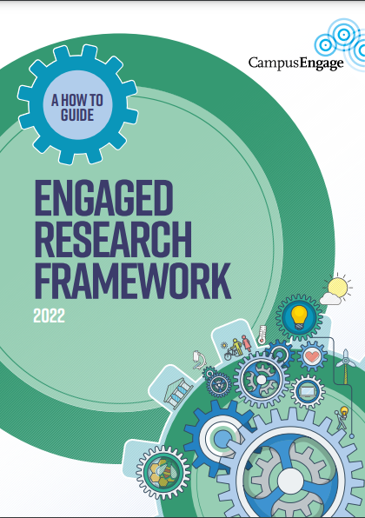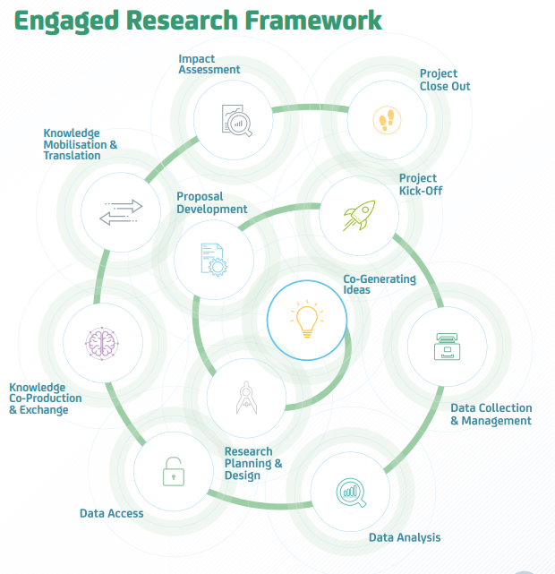 | Campus Engage. Research Framework 2022. A Framework for Engaged Research Society and Higher Education Addressing Grand Societal Challenges Together. A How to Guide.  https://www.campusengage.ie/wp-content/uploads/2022/03/Updated-Final-PBS10553-IUA-Engaged-Research-Framework-2022_V7.pdf
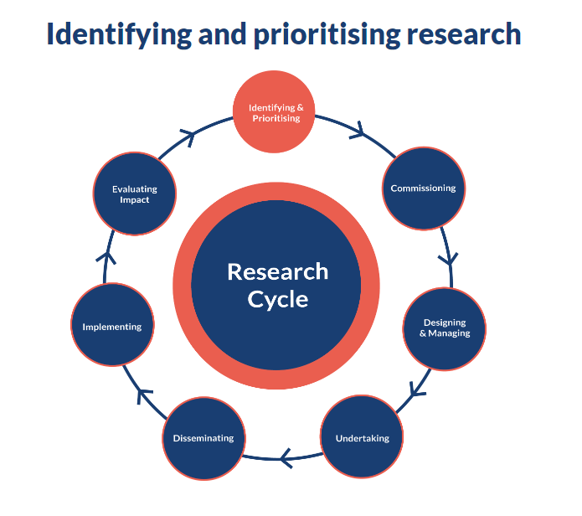 | NIHR. Briefing note eight: ways that people can be involved in the different stages of the research cycle. In: Briefing notes for researchers, April 2021  https://www.nihr.ac.uk/documents/briefing-notes-for-researchers-public-involvement-in-nhs-health-and-social-care-research/27371
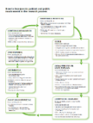 | NIHR RDS South Central. Diagram that explains how patient and public involvement can occur at different stages in the research cycle.  https://www.rds-sc.nihr.ac.uk/information-for-researchers/
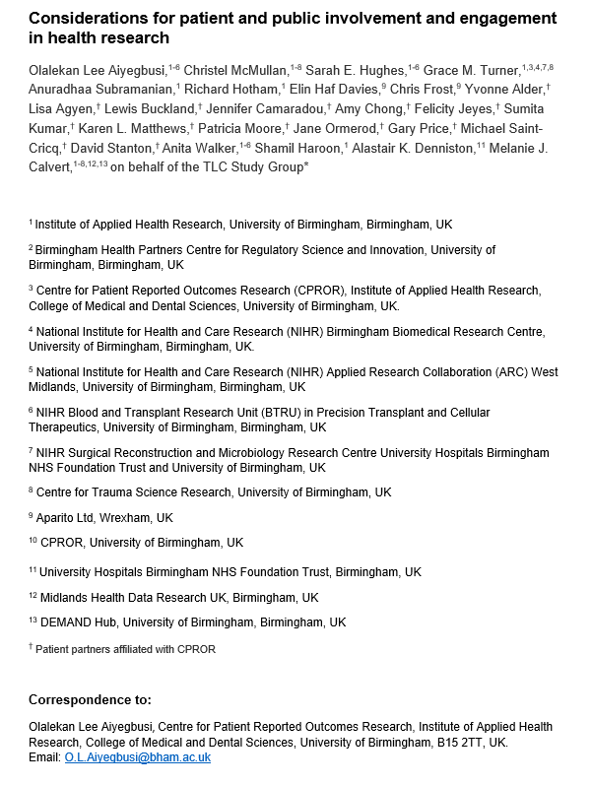 | Aiyegbusi OL, et al. Considerations for patient and public involvement and engagement in health research. Nature Medicine (in press).

- WHY: A good PPIE plan has purposeful activities based on mutual respect and benefit

This diagram from i2S Stakeholder Engagement Options Framework illustrates how you can increase the influence of patients and the public in research.
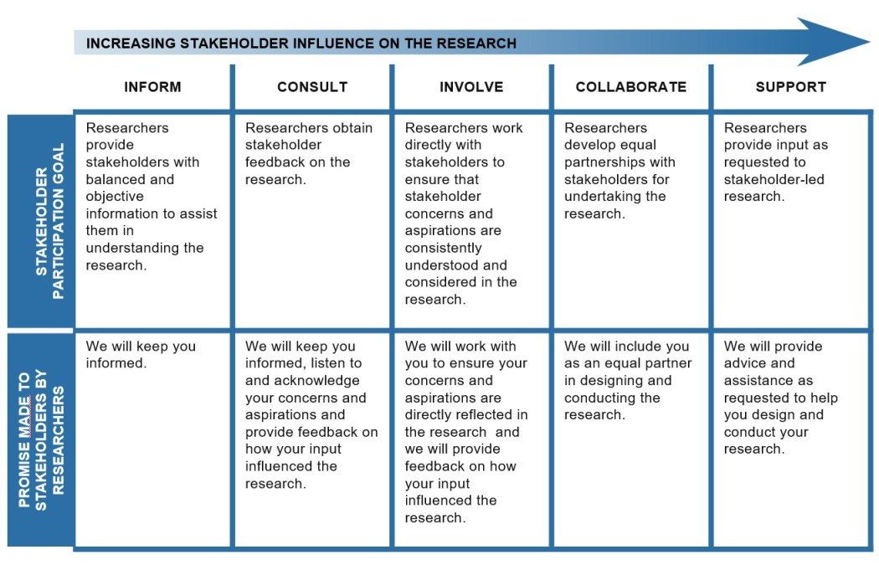
i2S Stakeholder Engagement Options Framework [modified from the IAP2 (International Association for Public Participation) public participation spectrum]. (Bammer G., 2021). https://i2insights.org/2021/11/04/options-for-engagement/

- HOW: A good PPIE plan has purposeful activities

There are many activities that you can use to involve or engage people. The choice of methods will depend on what you want to achieve, the timeframe and available resources. Some examples are listed below. You may already have preferences or experience of these approaches. However, if not, the PPIE team can help you to explore the different options, and provide support and training.

Inform Co-production

Websites | Work with patient groups/charities | Co-applicants
Case studies/ pen portraits | Work with community groups | Steering groups
Written articles (e.g., magazines, newsletters) | Attend existing community or PPIE events, | Co-researchers (e.g., literature reviews, interviews, analysis)
Lectures and presentations | Interactive websites | Patient/public led-activities
Webinars | Focus groups, world cafes | Expert/user panels
Social media, blogs, vlogs | Online consultations/forums | Buddy systems
TV and radio | Public debate | Research review/away days
Exhibitions, posters, displays, | Opinion polls | Co-chairs/facilitators
Art and performance | Science festivals, open days | Co authors
Videos and animations | Collaboration with artists | Co-presenters
Podcasts | Attend public events (festivals) | Trainers/educators

Section 2: PPIE Plan – for completion

Question 1: Which patient and public groups are relevant to your research?

Patient and public contributors should reflect the population that the research is aimed at. Think about:
- Who is the research intended to benefit (i.e., the target population)?
- Who might have ‘lived experience’ of the conditions/treatments of interest?
- Who is at risk of the condition?
- Who is under-served? For example, groups with lower inclusion in research than one would expect from population estimates or less likely to engage with health interventions.
- What patient characteristics are relevant (condition, trajectory, experience)?
- Who might contribute to the success of your research now or in the future (e.g., potential donors)?
- Important intermediaries (groups who may facilitate links between the research and other stakeholder groups)

List the different groups that we should try to involve or engage with. | Do you have existing contacts who might help us access this group?
(Please expand as needed)

Question 2: How will you integrate patients and the public into your decision making?

Co-production involves working together to make decisions with patients and the public; based on genuine power-sharing. This does not mean that patients and the public will choose to be involved in the day-to-day decisions that you might make, nor will they want to share responsibility for all aspects of the research. What is does mean, however, is that patients and the public should be involved in making key decisions that affect the direction, conduct and implementation of your research.

Think about:
- Your existing structures to make critical decisions.
- Regular review or away-days. E.g. Are there parts of the agenda that you could invite members of the PPIE to join you (e.g., to learn from them, participate in training that is relevant to all such as diversity training, or jointly plan future events and outputs)?
- Reporting mechanisms and obligations. E.g., can public contributors input into funder reports or annual progress/supervision meetings?
- If your team would benefit from having regular meetings with the PPIE group to provide updates and plan next steps
- If researchers might benefit from having individual patient consultants/buddies – to contact on a more ad-hoc basis
- How you could work in partnership to support key decisions (e.g., including public contributors in staff interview panels, meetings to gain regulatory or ethical approvals, building relationships with other organisations or companies)

How do you plan to involve patients and the public in decision-making? (please expand as needed) | Time frame (approximate) | Please feel free to add details, suggestions or ask for advice.
- Project Management Group (this has already been established) | Quarterly | The BTRU Project Management Group has two patient representatives who will act as a bridge between Theme Leads and the PPIE groups.

Question 3: What are the opportunities for PPIE - that adds value to your research?

We need to map PPIE to your research plan. The simplest way to do this is:

- Establish a calendar with deadlines, planning periods, research tasks/milestones, and important meetings or events – covering the duration of the programme. We appreciate that some of these may change or be vague at the moment. (What and When)
- Then think about how PPIE could add value to each of these tasks or milestones. Think about the specific outcomes. (Why)
- Then think about potential activities (How). We acknowledge that you may need some advice and support to understand and choose options. So do not expect substantial detail.

You can use your own approaches for planning. For example, you could map PPIE to an existing Gantt chart, make a logic model or use an excel spreadsheet.

Alternatively, you can use the template below; organised in relation to the research cycle. This includes a few hypothetical examples to get you started and show the breadth of what might be included (and which can be deleted).

Identifying and prioritising (producing research that is relevant, acceptable and valuable to the public)

This includes (but is not limited to): priority setting, mapping the research landscape, literature/data/policy reviews, agreeing research aims, discussing ethical issues, bid writing, sense-checking relevance and acceptability of aims/methods, prioritising or choosing between options, lay summaries, identifying stakeholders etc
What (research tasks & milestones) | When | Why | How
(as an example) Agree research aims and objectives | June 23 | Need to choose between several potential options. Would like to know what is most relevant and acceptable to patients and public, and to see if they generate alternative suggestions not yet considered by the research team. | Create an opportunity to hear lived experiences of being a patient or a family member at different stages in the illness trajectory. Perhaps a public poll?
(as an example) Develop a lay summary | July 23 | To have an accessible summary for website and first contacts with public. May be helpful to explore content and use of language – and if alternatives to a written summary would be useful. | Joint meeting with PPIE group to generate ideas and make plans to co-produce a summary.
Design & managing (producing research that is likely to be ethical, feasible, representative, unbiased, effective, value for money)

This includes (but is not limited to): Staff recruitment, protocol development, regulatory/ethical approvals, steering and decision-making, research design, data protection, risk management, budget management, annual reporting, etc
What (research tasks & milestones) | When | Why | How
(as an example) Set up interview panels to appoint new research staff. | 20th June 23 | Signal that PPIE is important to interviewees at outset and support early-relationship building. | Have public contributor input into job description and ask a patient to join interview panel.
(As an example) Gain Ethics approval | End of Aug 23 | To ensure research is acceptable to patients/public. | Ask public contributors to co-produce appropriate sections of ethics submission. Invite one to also attend Research Ethics Committee meeting.
Undertaking the research (producing patient-focused research that is undertaken and managed successfully)

This includes (but is not limited to): Quality control, identifying resources/skill-sets needed, creating conducive research environments, developing effective and acceptable data collection methods, producing public-facing research materials, appropriate recruitment and retention, interpretation of results, problem solving, motivating/inspiring/challenging staff, etc
What (research tasks & milestones) | When | Why | How
(as an example) Sense check interim thinking, interpretations and future plans | Annually | To remain focused on potential implications of work for patients and public, help staff remain motivated, understand what aspects are interesting/concerning to a public audience. | Hold an annual update meeting – perhaps to coincide with an existing event (e.g., project management meeting, away day). Co-produce agenda with patients/public to ensure mutual benefit.
(as an example) Develop patient recruitment strategy. | Jan-Mar 24 | To optimise recruitment, selection and retention - minimise distress. Explore barriers/facilitators, particularly in relation to under-served groups. | Half-day workshop to co-produce strategy with public contributors – with at home activities to co-produce recruitment materials including patient information, distress protocol. Perhaps make a recruitment video focusing on under-served groups? Perhaps train a patient to be a research recruitment champion?
Dissemination (producing research that accessible, transparent and transformative)

This includes (but is not limited to): Raising awareness of BTRU/research/organisation involved, sharing interim and final findings, building networks, producing accessible and novel communications, press and policy briefs, academic and lay publications, dissemination events, presentations, creative/social/artistic media, etc
What (research tasks & milestones) | When | Why | How
Contribute to Calendar of Events developed by PPIE team. | Ongoing (as identified by us or PPIE team) | Raise awareness and engage people by routinely showcasing research and PPIE as part of national campaigns, awards and awareness days. | Social media, support BTRU events or participate in existing initiatives. E.g., World Cancer Day
(as an example) Publish research protocol. | Oct/Nov 23 | Invite public contributors to co-author the research protocol in peer reviewed journal, to ensure their contribution is recognised. | Share the draft document with a glossary of terms for input to appropriate sections. Offer several ways to input and feedback.
Implementation (producing research that is acted upon and has a lasting legacy)

This includes (but is not limited to): Knowledge brokerage events, mapping findings to policy/practice, developing implementation resources, identifying outputs/intellectual property/commercialisation activities, developing proposals for spinout projects, engaging in training/education, planning end-of-project events to thank public contributors and support closure or legacy.
What (research tasks & milestones) | When | Why | How
(as an example) Secure new research funding. | TBC – as identified | Work with public contributors to prioritise research questions and develop new bids. | Ask PPIE groups for views on potential options and to co-develop PPIE strategy for bid. Identify patient co-applicant to help co-chair PPIE work.
Evaluating Impact (producing research where the value of PPIE is understood)

This includes (but is not limited to): Formal and Informal feedback from public contributors/public/researchers/partners/funders, reflective processes, significant event analysis, use of analysis tools, developing improvement strategies, recommendations or tools.
What (research tasks & milestones) | When | Why | How
(as an example) Develop PPIE impact case studies specific to my work. | At end of key milestones TBC | To show mutual impact of PPIE on work – to demonstrate impact to public and funders, but to also demonstrate own learning to support career progression and organisational reputation etc | Video of interviews with staff and public contributors - for use on BTRU website and to provide quotes for key documents and reports. Perhaps work with graphic facilitator/artist to show impact visually for lay audience?

© The University of Birmingham, 2023. This work is licensed under the Creative Commons Attribution 4.0 International License. To view a copy of this license, visit http://creativecommons.org/licenses/by/4.0/

