Pedagogical guidelines and sample activities for the teaching of Tense and Aspect combinations in English following insights from error-driven associative learning
- General recommendations
  - Intro: different types of cues
  - The rarer TAs and how to approach them
- Simple tenses
  - The present simple
  - The past simple
  - Contrasting between present simple and past simple
- Perfects
  - Overall observations
  - Present perfect vs. past perfect
  - Present perfect vs. past simple
- Progressives
  - Overall observations
  - Present progressive vs. past progressive
  - Present progressive vs. present simple
- Future simple

- General recommendations
In order for language structures to be effectively acquired by L2 learners it is important to implement a method that relies on strong contingency of cues and outcomes, that is, strong association between lexical or contextual elements and tense and aspect structures. In the case of TA combinations, this implies identifying which elements are prototypically associated with a TA and are reliable indicators, or cues, for a given structure. As argued in Romain, Ez-Zizi, Milin, and Divjak (2022), for TA combinations, these reliable indicators are of two types: either lexical or contextual. In the case of lexical cues, the best indicators for the use of a TA are offered by the verbs themselves, and contextual elements need not be invoked. For example, “replied” is among the most frequently used verbs in the simple past. On the other hand, where TAs are cued by contextual elements, it is important to look beyond the verb, into the wider (sentential) context. For instance, the present perfect is supported by adverbial phrases such as since then. For learning to be successful, it is crucial that instructors be able to draw learners’ attention to the optimal type of cue for learning to use a particular TA.
To facilitate learning, we advocate starting with those tenses that make up the bulk of usage. Not only will this help learners to quickly start using TAs appropriately in the majority of cases, but it will also help them build up towards the rare and more complex cases. Our assumption is that once learners have understood how to use the most frequent TA combinations presented below, they will be able to use their knowledge of these combinations to apply them to less frequent TA combinations. This assumption is justified as our study shows that the cues that are the most strongly associated with perfect progressives, for example, are a mix of the cues found for the perfect on the one hand and the progressive on the other. Therefore, it is expected that once a learner has grasped the use of the perfect and of the progressive, they should be able to understand in which contexts to use the perfect progressive forms. The same holds for the future perfect and the future progressive.
- Simple tenses
The two simple tenses, namely present simple and past simple, rely essentially on lexical cues; that is, it is the verb lemma that is the most reliable cue for the use of these TAs. It is therefore crucial to direct learners’ attention to the verb itself. We will present some examples and suggestions below for the present simple and past simple individually.
  - The present simple
The use of the present simple can be broadly divided into three main categories: with verbs of emotion, verbs of mental state, and verbs of logical state. Of course, there is more to the present simple than these three categories, but they do represent a large amount of the uses of this TA combination and should therefore be presented extensively and coherently at the start of a TA learning programme. The key with the present simple will be to direct learners’ attention to the relevant cue, i.e., the verb (and to some extent the kind of event/situation it denotes). A suggestion for a first exercise would be to have learners sort example sentences into three groups without giving any instructions but by using boldface or italics to direct learners’ attention to the verbs. They don’t necessarily need to label the groups, the idea would be to let them follow their instinct. For this first exercise we have chosen verbs that are frequent, prototypical, and quite general or accessible. We have also deliberately used first person subjects for verbs of emotion and of mental state and 3rd person subjects for verbs of logical states, as this is a trend we noticed in our data. Once learners have sorted these sentences into groups, the instructor can label the three main groups of verbs used in the present simple as verbs of emotion, verbs of mental state, and verbs of logical states.
Exercise suggestion:
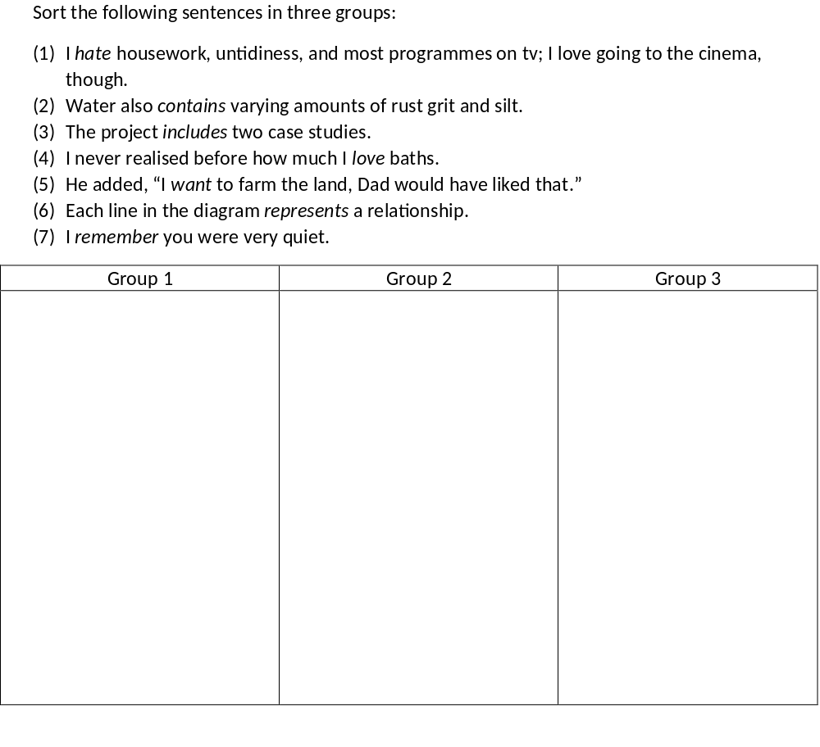
Once this is done and learners have identified the three main semantic groups of verbs used in the simple present, we suggest that the instructor extend this exercise by providing a few more examples with other verbs as in the following.
Exercise suggestion:
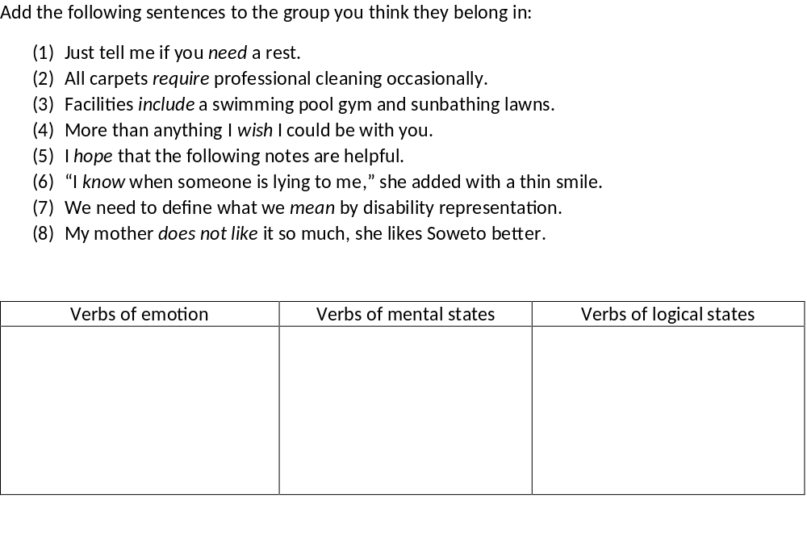
Another suggestion for classroom activities is having learners read longer chunks of text, identify uses of the present simple and highlight the relevant cues, i.e. verbs. Here is an example of such a short text, expanded from one of the extra examples below:
- The fields and woods contain squirrels, badgers, and red deer. The little village of Grasemere has inspired many of our great artists and poets including Wordsworth, Coleridge and Ruskin. If you feel like a gentle lakeside stroll Grasmere Lake is to hand, or for the more energetic, Helvellyn, the most climbed peak in England, rises up only a short distance from the village.
We provide extra example sentences below that contain the top cues for the present simple.
Emotions:
- I hate people like Vera.
- I just love her little car.
- He says he loves me.
- The locals, however, love their feast and take it seriously.
- “I just want some time to myself,” she repeated calmly.
- When pigs want other pigs to follow them, they hold their tails erect.
- She wants to play at the highest standard.
- I just need someone to help with the paperwork.
- Maybe he needs to get a breath of fresh air.
- I like that part of the game.
- I like railway stations, you know, how big and noisy and busy they are!
Mental states:
- If patients wish to give up coffee, it is perhaps not a bad thing.
- I hope you did not fiddle with your food.
- I hope that someday I will be able to make more contributions.
- “But I don’t remember it at all,” she said solemnly.
- Now you know what I have to put up with.
- He should refrain from making comments on subjects he knows little about.
Logical states:
- “I don’t know what you mean,” she said shortly.
- What I mean is my headache has gone.
- The project represents an extension of work based on earlier small-scale surveys.
- Each line in the diagram represents a relationship.
- Each book contains ten reading texts followed by short and varied exercises.
- The fields and woods contain squirrels, badgers, and red deer.
- Water also contains varying amounts of rust grit and silt.
- Our profession requires complex and varied knowledge, skills, and attitudes.
- The project includes two case studies.
- Each packet includes a leaflet giving full instructions for successful cultivation.

  - The past simple
Just like the simple present, the past simple is also mostly lexically supported, which means that learners’ attention should be oriented towards the verbs. Again, we can divide our verbs into two semantic groups and can therefore propose the same exercises as for the present simple. The two groups for the past simple are verbs of reported speech and verbs of reaction. The ‘verbs of reported speech’ category is rather straightforward and encompasses verbs such as say, reply, answered, but also less obvious ones such as whisper, mutter, or shout. The verbs of reaction contain a slightly more mixed bag of verbs such as smile, shrug, or nod. Again, we have deliberately made the first exercise somewhat easy by using highly frequent verbs and by using examples in which the verbs of reported speech are used with clear indications of speech, i.e., inverted commas. This helps clearly separate the two groups.
Exercise suggestion:
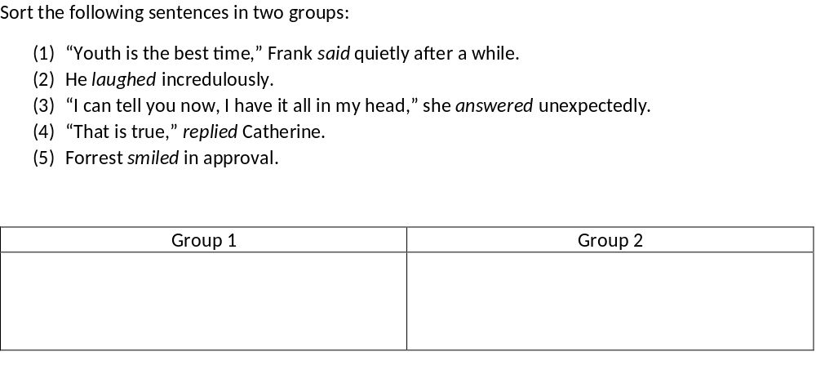
Next, the same can be done as with the present simple. Once the semantic groups are revealed, learners are asked to add sentences to the group they think these sentences belong in. This time, we included slightly less frequent verbs and included one example where the verb of reported speech is used for indirect speech (thus without the commas).
Exercise suggestion:
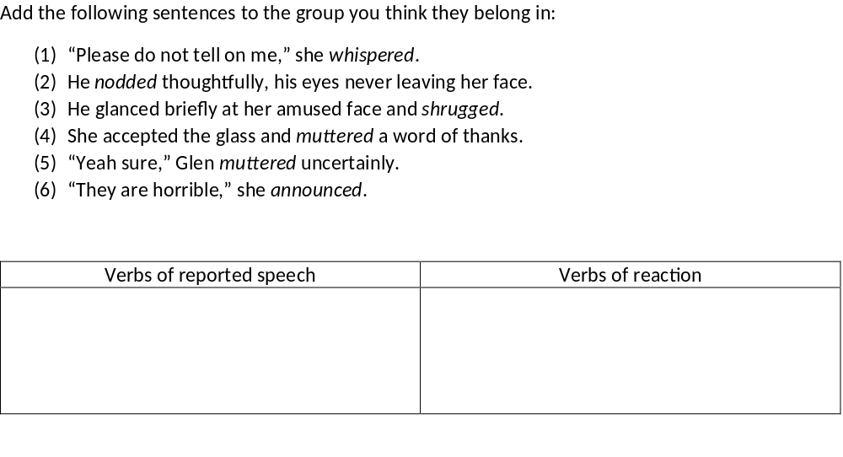
We also provide a list of extra examples for each group below.
Reported speech:
- “Not if I can help it,” he replied grimly.
- “Not at all,” she replied, as she shuffled her papers into a neat pile.
- “Apparently not,” she whispered as her eyes filled with stinging tears.
- “She does come from Croydon,” said my mother.
- “I don’t know,” he muttered.
- “I would love to,” I answered.
- “You did not answer me, Gregor.”
- And finally he announced that another referendum would be held in January.
- “I know when someone is lying to me,” she added with a thin smile.
- “I was counting every vote with him,” he added.
Reaction:
- I dropped my eyes and nodded sheepishly.
- Blanche smiled to herself as she realised that he was unaware of the irony.
- He smiled warmly.
- Sam shrugged at me.
- Willie shrugged his shoulders.

  - Contrasting present simple and past simple
Finally, we suggest an exercise to help learners identify the contrasts between the two TA combinations and the verbs that are relevant for these TA combinations. In this exercise, learners are asked to match the verb forms with the correct sentences. While there is the same number of verb forms and empty slots, some verb forms will match several sentences. This could be an opportunity to ask learners why several verbs can be used in the same context and what that implies for the verbs and TA combinations.
Exercise suggestion:
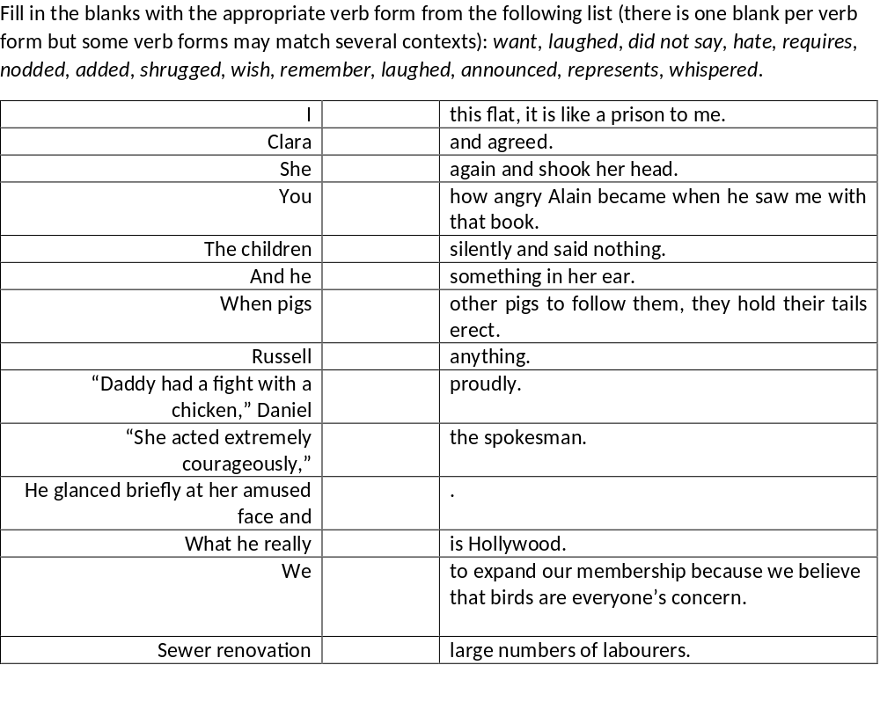
We also provide the solution with the original sentences below.
I | hate | this flat, it is like a prison to me.
Clara | nodded | and agreed.
She | laughed | again and shook her head.
You | remember | how angry Alain became when he saw me with that book.
The children | laughed | silently and said nothing.
And he | whispered | something in her ear.
When pigs | want | other pigs to follow them, they hold their tails erect.
Russell | did not say | anything.
“Daddy had a fight with a chicken,” Daniel | announced | proudly.
“She acted extremely courageously,” | added | the spokesman.
He glanced briefly at her amused face and | shrugged.
What he really | represents | is Hollywood.
We | wish | to expand our membership because we believe that birds are everyone’s concern.
Sewer renovation | requires | large numbers of labourers.

- Perfects
  - Overall observations
The perfects are mostly supported by adverbials, but some verbs also support these TAs directly. We will first provide a list of examples to illustrate the typical contexts in which the present perfect and past perfect are used. We will then zoom in on the comparisons between present perfect and past simple and present perfect and past perfect.
The top adverbial cues for the present perfect are already, since then, ever, and so far. All these are used in contexts where speakers report on events and their consequences (or lack thereof) for their then present time. Similarly, a number of the verb cues that support the present perfect denote change (or lack thereof) as in change, developed, or evolved. The contextual cues can easily be added to many instances of the present perfect, showing some harmony in the uses of the present perfect. Therefore we suggest an approach in three steps. First, an exercise on the adverbials and their similarities/differences, then a similar exercise with the three verbs mentioned above. Finally, we suggest one last exercise where learners combine verbs and adverbial cues. The aim of these exercises is to have learners think about the kind of contexts in which the present perfect is used and see the similarities between a number of exemplars.
The first exercise is a ‘fill-in-the-blank’ type of exercise where learners have to assign one or several adverbials to each sentence. The instructor’s task is to have the students match the adverbials with the sentences. When a context allows different adverbials, students should be encouraged to discuss whether the use of different adverbials affects the meaning of the sentence. This should lead them to an overall understanding of the uses of the present perfect. The original sentences are provided below.
Exercise suggestion:
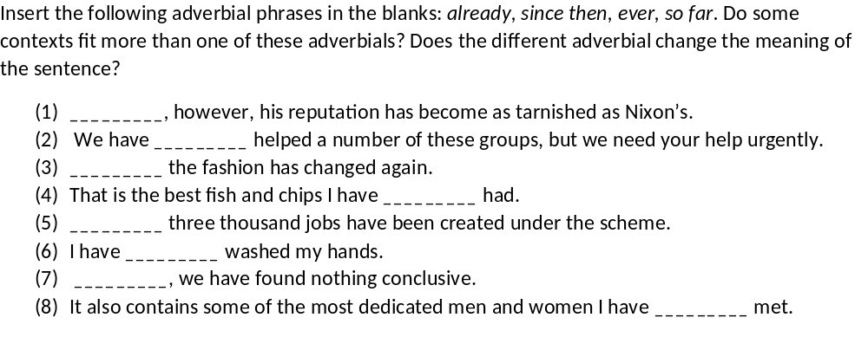
Extra exemplars of adverbial cues for the present perfect
- We have already made some progress.
- I have already asked for information on all members of the party.
- Unfortunately there have been a few more hurdles since then.
- You are the most contemptible individual I have ever encountered in my life.
- That is the only silly thing you have said so far.
Since a number of the top verb cues for the present perfect share a similar meaning, we propose an exercise where learners are asked to consider these verbs in context and assess whether they are interchangeable.
Exercise suggestion:
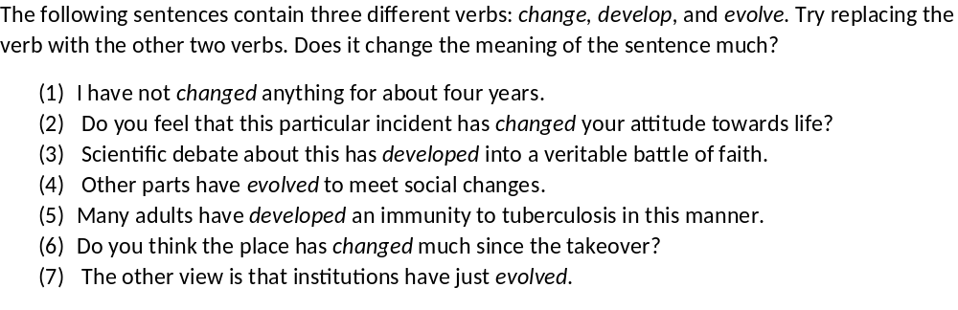
Finally, we suggest an exercise combining the verb cues and the adverbial cues. Learners are encouraged to think about the compatibility of these two types of cues in order to better assess when to use the present perfect.
Exercise suggestion:
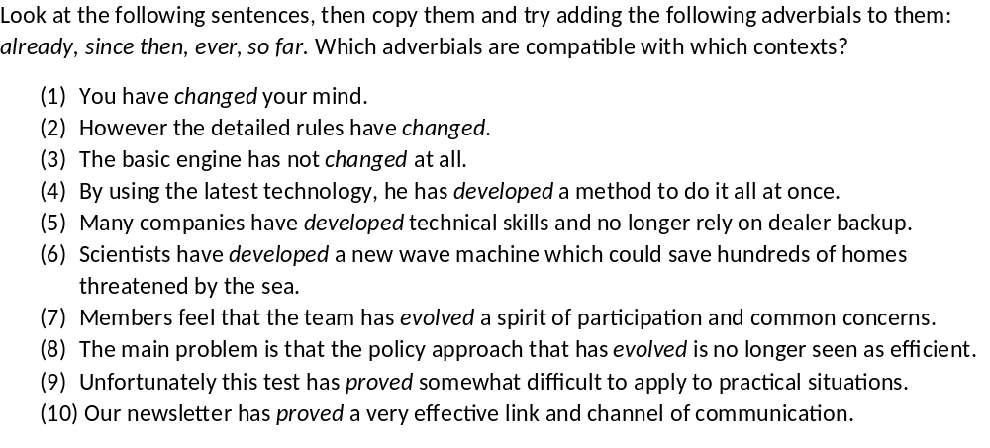

Extra exemplars of verb cues for the present perfect
- He has not changed much.
- Thus we have developed a distinctly new product especially to meet the demands of this market.
- The tunnel has proved incomparably more expensive than at first imagined.

  - Present perfect vs. past perfect
The top adverbial cues for the past perfect are similar to those that support the present perfect such as never, already, or ever, but also the 4-gram it was the first time. Interestingly, the top 2 verb cues for the past perfect are finish and cease, which are semantically rather similar, but semantically different verbs also appear among the top cues such as forget, disappear, and fail. Since the present perfect and past perfect are very similar and rely on the same cues to some extent, we suggest drawing learners’ attention to the main difference between the two: anteriority. We thus recommend having learners compare sentences in the present perfect and past perfect and discuss differences.
Exercise suggestion:
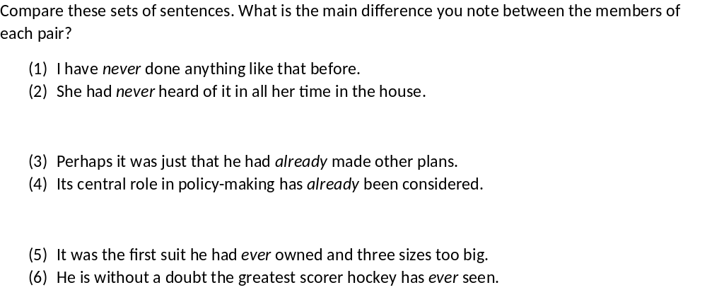
Once learners have discussed the notion of anteriority, they should be presented with other examples of cues that are particularly relevant for this feature of the past perfect such as previously and it was the first time. We provide a sample below:
- The budget is the one that had been approved previously.
- Killy had been triple gold medallist four years previously at Grenoble.
- It was the first time they had ever spoken of the affection they felt.
- It was the first time I had ever seen myself on screen.
So as to further exemplify this notion of anteriority, we can also make use of the verb cues that support the past perfect. This way, learners’ attention is drawn to the verb as well.
Exercise suggestion:
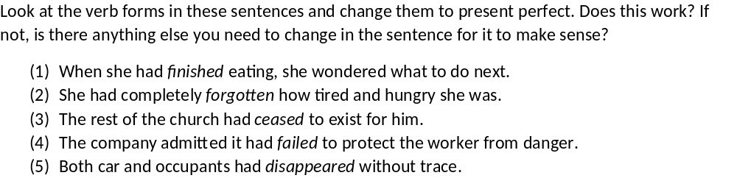
Extra exemplars for the past perfect:
- They were her father’s words and she had never forgotten them.
- He had already made speeches in favour of European co-operation and even of a Franco-German union.
- She had finished the sewing part and was now knitting its little coat.
- He turned to look at her almost as if he had forgotten she was there.
- The world had ceased to exist.
- The chair I had supposedly used on the policeman had disappeared, obviously thrown away.
- Successive security council resolutions had failed to produce results.

  - Present perfect vs. past simple
So far, we have shown examples for the present perfect and the past simple individually, but it is commonly agreed/observed that learners struggle to understand the difference between the two TAs. We thus suggest using examples of sentences containing the top verb cues for the past simple but used in the present perfect. These sentences contain adverbials that should help learners explain why the verbs are used in the present perfect in these cases, thus making them think about the cues for the present perfect, despite the use of the top cues for the past simple.
Exercise suggestion:
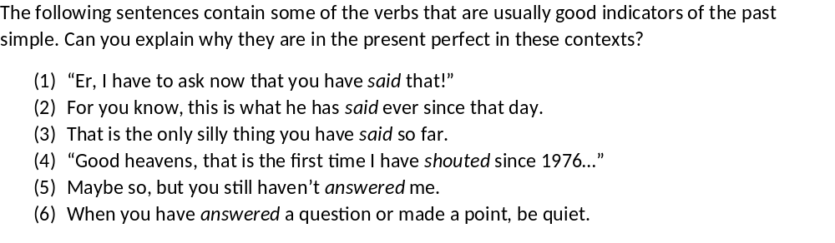
- Progressives
This section will present suggestions for the teaching of both present progressive and past progressive. We will start with general observations before sharing suggestions to contrast between present and past progressive.
  - Overall observations
As we mentioned in the main paper, the present progressive and past progressive both rely to a large extent (in around 75% of cases) on lexical cues, and the contextual cues that appear for these combinations are mostly irrelevant as they form part of phrasal verbs. We will therefore focus on lexical cues for teaching purposes.
The verbs that are strong cues for the present progressive denote actions that usually require some time or can easily be construed as ongoing. We therefore suggest an exercise in which learners’ attention should be drawn to the verbs in the examples and their meaning. This can be achieved by presenting them with a list of exemplars and asking them to think about what the sentences have in common.
Exercise suggestion:
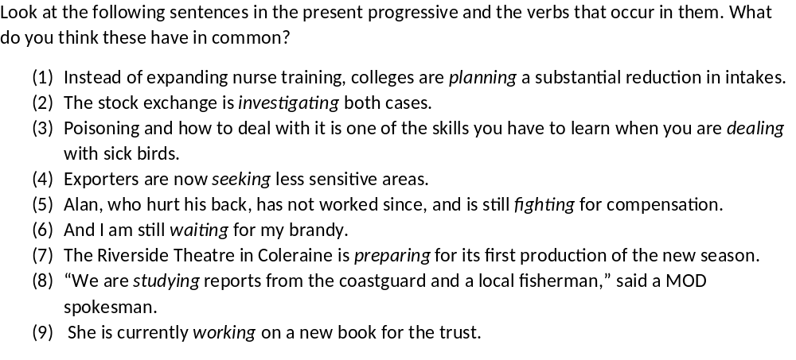
As it has also been observed that some learners tend to struggle when choosing between the present simple and the present progressive, it would be relevant to have them turn some present progressive sentences into present simple forms and ask them to assess whether the use of the present simple is possible without changing anything in the sentence, and if so, how it changes the meaning of the sentence.
Exercise suggestion:
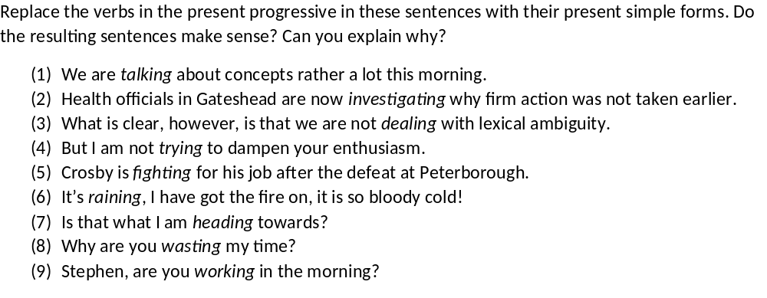
  - Present progressive vs. past progressive
The top verb cues for the past progressive are verbs such as wear, talk, wait, or head. Many of them are shared between the present progressive and the past progressive. The difference between the two TAs, just like the perfects, resides mostly in anteriority. It is therefore relevant to point this out to learners, or rather, let them identify this difference. We thus propose an exercise in which learners have to experiment with both combinations and decide if they are both appropriate for the context.
Exercise suggestion:
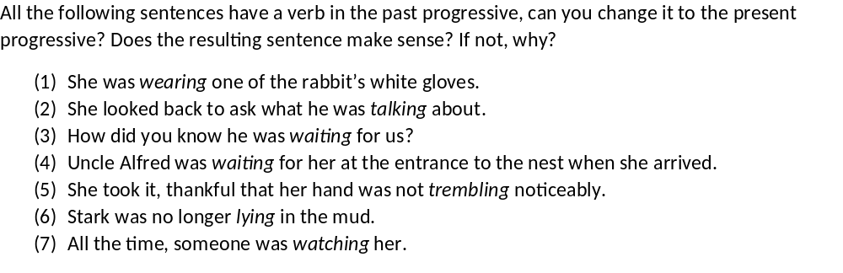
  - Present progressive vs. present simple
Learners also sometimes struggle to differentiate between present simple and present progressive. In order to draw their attention to the differences between the two forms, we suggest an exercise where the same verbs are used in both forms in different sentences/contexts. These verbs are among the top cues for the present progressive, which should lead learners to think about their use in the simple form.
Exercise suggestion:
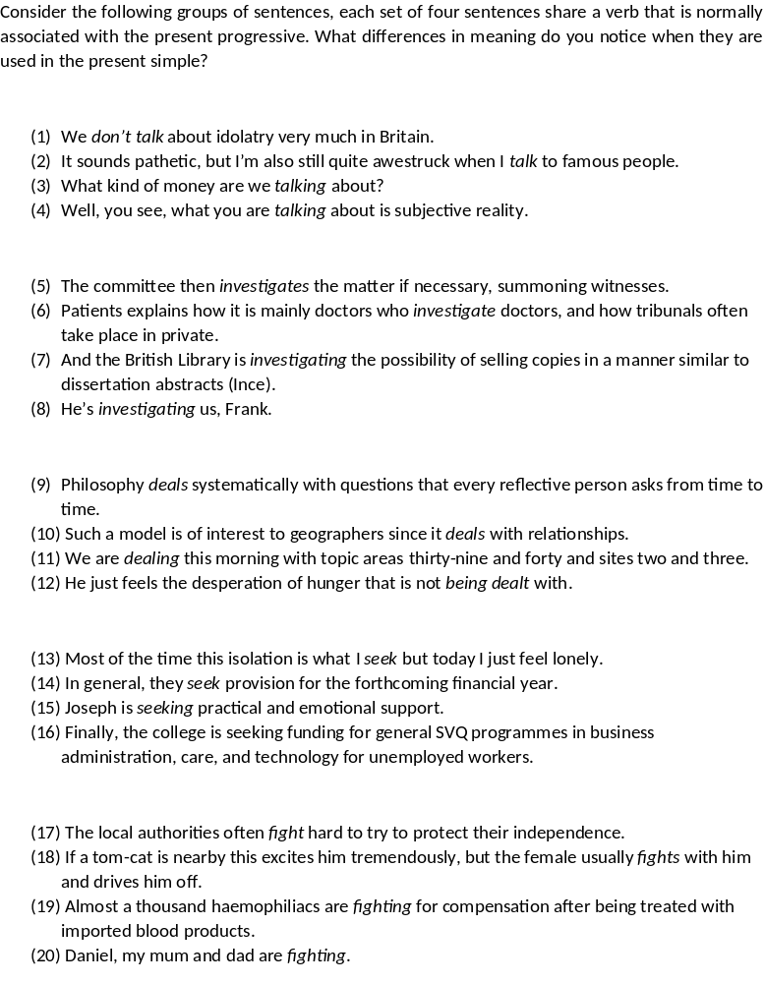

- Future simple
The future simple is predominantly contextually cued and some of these contextual cues are easy to associate semantically with the future, notably the two related n-grams hopefully and it is hoped. As to the verb cues that support this TA, some can also be related to hopes and promises such as benefit, help, ensure, and continue. In order to draw learners’ attention to the contextual cues, we suggest an exercise that asks them to look for the cues: “what these sentences have in common.” Note that all sentences but one contain a time adverbial (this summer, this year, at the end of the week, when she wakes up); so there is a chance that learners will focus on these but the inclusion of the last sentence that contains no such phrase should help them focus on the target cues it is hoped and hopefully.
Exercise suggestion:
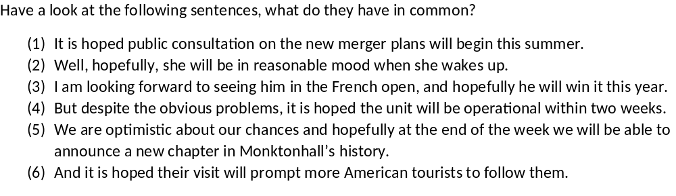
As we mentioned above, the top verb cues for the future tend to denote events related to promises, guarantees, or hopes. Such cues include benefit, help, or ensure, but also continue and result. Since there are no clear-cut semantic groups among these verbs, we suggest an exercise that will have learners focus on the verbs by having them fill in the blanks with the appropriate verb. Some verbs may be appropriate for more than one context but this shouldn’t be an issue as the focus is on the compatibility and representativeness of these verbs with the future simple.
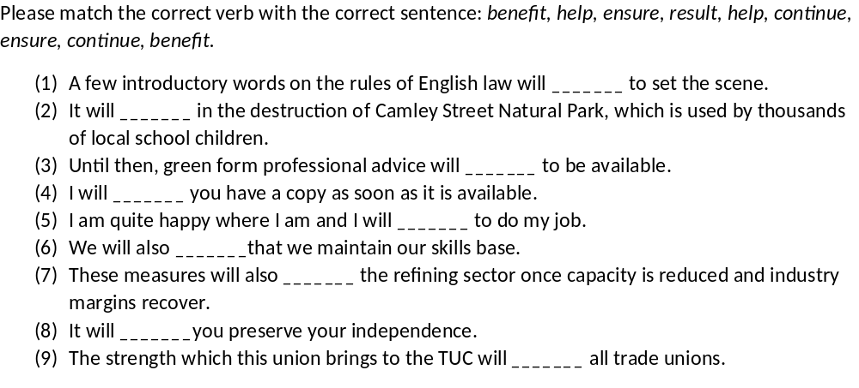
Extra exemplars for the future simple:
- And it is hoped work will continue after the initial two years, perhaps with support from the business community nearby.
- It is hoped that once building work at Manor Farm has been completed there will be a considerable reduction in the amount of traffic along the brook.
- It is hoped that work will begin on it later this year.
- However, sponsorship is being sought for the next term and it is hoped sufficient funding will be secured to avoid a repeat fee.
- It is hoped that the builders will be on site by July and the first shops will open by Christmas.
- Hopefully he will recover well and be back to normal.
- It has been hard going for us all in the league, but hopefully this result will help bring back the confidence.
- Hopefully though, it will give people some kind of a handle on these issues to use in relation to other films.
- Pupils will benefit and that must be the object of the exercise.
- Anything done to increase either will benefit the company.
- Regular usage will help to pinpoint a problem before it turns into a crisis.
- The method of access will also help to determine the length of the pit.
- I confirm that the battalion will continue.
- In particular, rights and obligations arising from the treaty on the of nuclear weapons of July will continue to apply to the united Germany.
- And will then continue normally again from the rear edge.
- The government is hoping support will ensure a speedy passage for the law.
- Will you please ensure that this request is put before the appropriate committee as part of the coming budget cycle?
- Will he ensure that all discussions that take place are opened up for us to criticise and assist?
- This will result in greater focus on our business priorities and the needs of our customers.
- The normal expectation is that a request for exclusive acquisition advice will result in a engagement for the participating member firm.
- He has already been booked four times this season and two more cautions will result in automatic suspension.
- The attractive new environment created by the barrage will result in direct and indirect jobs.

Romain, Laurence, Ez-Zizi, Adnane, Milin, Petar, & Divjak, Dagmar. (2022). What makes the past perfect and the future progressive? Experiential coordinates for a learnable, context-based model of tense and aspect. Cognitive Linguistics, 33(2). https://doi.org/10.25500/epapers.bham.00004302, http://epapers.bham.ac.uk/4302/

